  - Managing Conflict Unit

Unit Overview
Unit Focus:
This unit focuses on how to identify and manage conflict, whether it is within us or around us.

Unit Outcomes: By the end of the Unit learners will be able to:
- Explore conflict in a healthy way.
- Recognize the inner strengths that help them move forward.
- Learn tools that help to calm the internal chaos.

Unit Weekly Themes:
- Recognizing Inner Conflict
- Finding Inner Strength
- Developing Tools to Manage Conflict
- Being a Calm Presence

Affirmations
- I am at peace in my heart, in my mind, and in my body.
- God’s love within me gives me all the inner strength I need.
- I am calm in moments of chaos; I am strong in the appearance of storms.
- I choose peace.

Bible Quotes
- So then let us pursue what makes for peace and for mutual upbuilding. Romans 14:19

- Bear with each other and forgive one another if any of you has a grievance against someone. Forgive as the Lord forgave you. Colossians 3:13

- Love is patient, love is kind. It does not envy, it does not boast, it is not proud. It does not dishonor others, it is not self-seeking, it is not easily angered, it keeps no record of wrongs. Love does not delight in evil but rejoices with the truth. It always protects, always trusts, always hopes, always perseveres. 1 Corinthians 13:4-7

- A hot-tempered man stirs up strife, but he who is slow to anger quiets contention. Proverbs 15:18

Unity/Fillmore Quotes
- Talks on Truth p84
In claiming your unity with Spirit, you must be willing to conform to the conditions of Spirit. If you are not sincere in your conformity, you will be torn in the conflict. You cannot worship two masters.

- Teach Us to Pray p40
We should bear in mind that God is our silent partner and that His wisdom and strength, His energy, and skill are ours to use.

- Myrtle Fillmore’s Healing Letters p121
God is providing, and directing, and prompting will give you great peace. You will also invite and lay hold of your own individual God-given resources. For in truth, God provides for you, and your blessings are not dependent upon others.

- Myrtle Fillmore’s Healing Letters p37
God is in us as the very life and substance that we use, and our use of God's gifts increases our ability to use and to direct them. God is life; we make that life into living. God is love; we make divine love into loving.

Children’s Lessons

#1 – Recognizing Inner Conflict

Opening Experience
Ahoy, mate! Welcome to the first week of the Managing Conflict Unit. Let us begin this week by embracing the peace in our hearts, mind, and body. God’s love within us, gives us all the inner strength we need. Repeat these words: I am calm in moments of chaos… I am strong in the appearance of storms… I choose peace.

Activity Choices

- Unity Basic Principle Activity
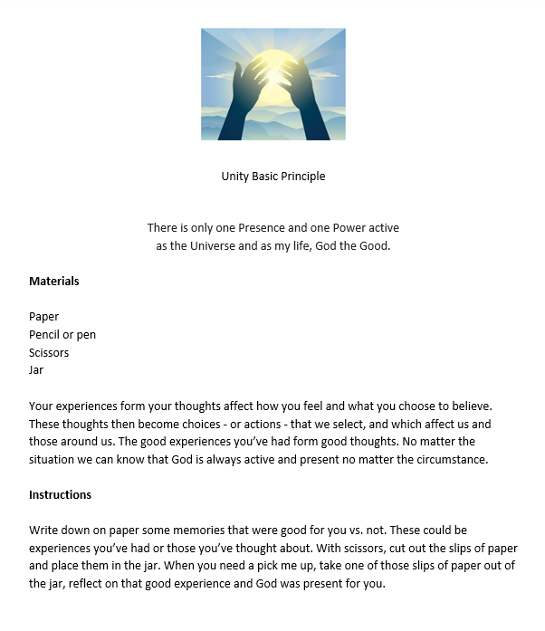
- Conflict Talk Sheet
https://www.plantlovegrow.com/conflict-resolution
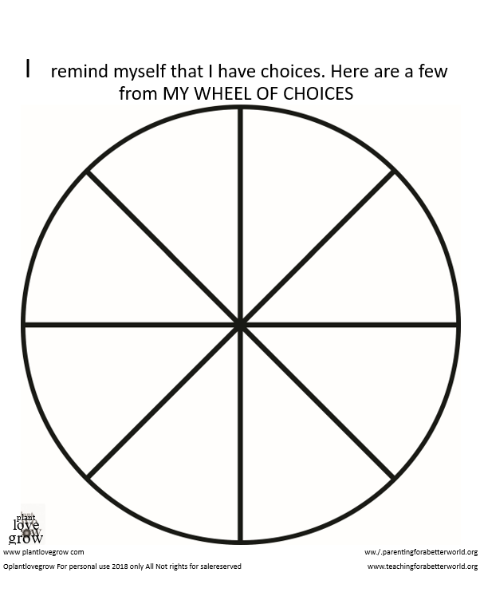

Meditation Zone
Welcome to the Meditation Zone. Let’s pause and listen to this meditation that helps us reclaim a calm mind and spirit. Add a square object or something to remind you to breathe to your sacred table and have fun with a feelings and emotions guessing game.
Activity Choices

- Calming Meditation
  - https://youtu.be/FKU6QwT8psY

- Guess the Feelings and Emotions
  - https://youtu.be/MeNY-RxDJig

- Square Breathing (Handout)
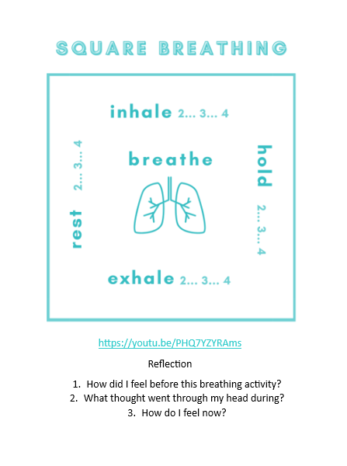

- Sacred Table Activity:
  - Add a square object or an item that serves as a reminder to practice mindful breathing

Media Room
Welcome to the Media Room. My, what a beautiful sunset! Click on the red stars to hear a story about exploring emotions by Paul Christelis, and then reflect on your own emotions and feelings about the story.

Today we will watch the video:
- Exploring Emotions by Paul Christelis
  - https://youtu.be/wwzWGijskso

Reflection Questions
- How do you see yourself in this story?
- How do you see this experience in your daily life?

Creation Station Activities
- Aloha from the creativity station! Dip your toes in the sand or the water and grab your art supplies. This week, we’ll explore with our imagination and make a colorful feelings wheel. Remember that no emotion is bad to have. Everything that you feel is valid and okay. It’s how we express those emotions that matter. Writing them down or talking them out when you’re feeling them is healthy and helpful.
- Feelings Wheel Handout
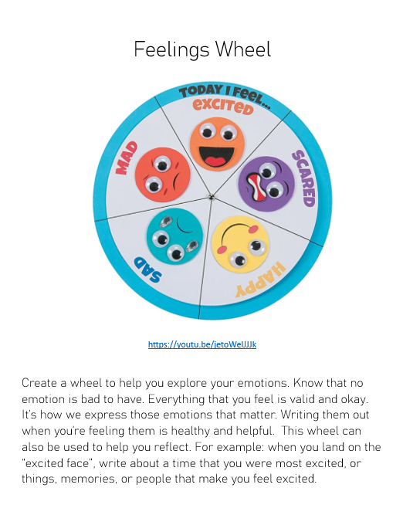
- Animal Charades Challenge
  - https://youtu.be/kiGkvmuz00k

#2 - “Finding Inner Strength.”

Opening Experience
Welcome to week 2 of Belonging. Now that we’ve practiced ways of identifying with and connecting to ourselves, we will begin our adventure of connecting with others. Remember, there is only one you and only one me, but we are both and all, only human. As humans, it is natural to desire relationships of various levels and connections with others. We will begin our journey with a creative, kid- lead video on tips for making new friends and then dive into some other fun activities to discover connecting with others, different and alike.

Activity Choices

- God’s Love Handout
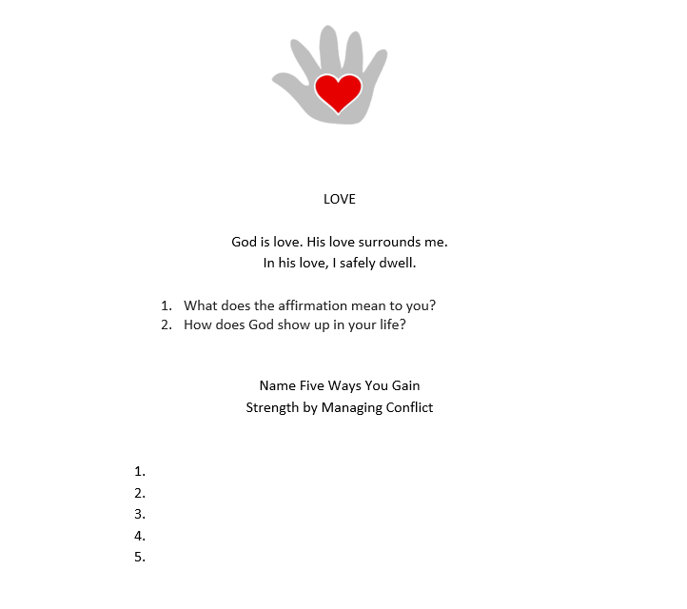
- Me Tree
  - https://www.actionforhealthykids.org/activity/create-a-me-tree-a-self-reflection-activity/

Meditation Zone
Soak up the sun while taking in an inner peace meditation and learn healthy mindful habits. Then, add to your sacred space with an item that represents or is a reminder to practice exercising daily mindfulness.

- Finding Inner Peace and Strength
  - https://youtu.be/sbmw_1Bl7LA

- Mindful Body Scan
  - https://youtu.be/xLoK5rOl8Qk

Heartbeat: A Mindfulness Exercise to Calm Your Emotions
  - https://youtu.be/3iUf73v92lI

- Sacred Table Activity: add to your sacred space with an item that represents or is a reminder to practice exercising daily mindfulness.

Media Room
Listen to the story, I am Strong, and think about some times that you have shown courage and strength.

- Today I’m Strong by Nadiya Hussein
  - https://youtu.be/Jmn8RtjAvQI

- Reflection Questions
- How do you see yourself in this story?
- When are some times that you have shown courage and strength?

Creation Station Activities
You are one of a kind! There is only one you…even if you’re a twin. This week, we will channel into some of your best qualities, that make you the rockstar that you are. We’ll also define resiliency, and how to best shape it within ourselves.

- Strengths and Qualities Handout
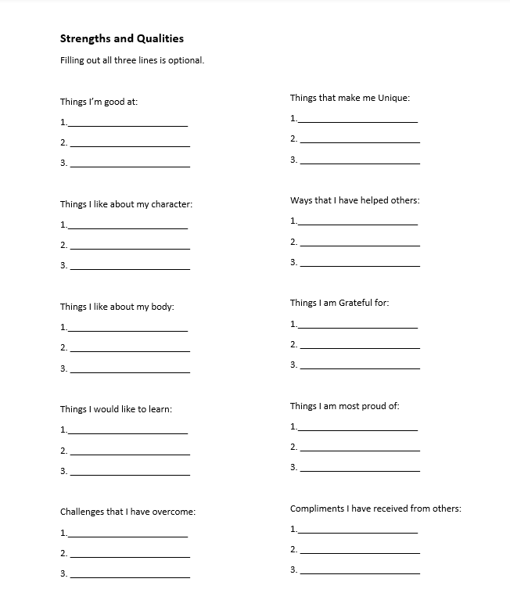
- Resiliency Alphabet
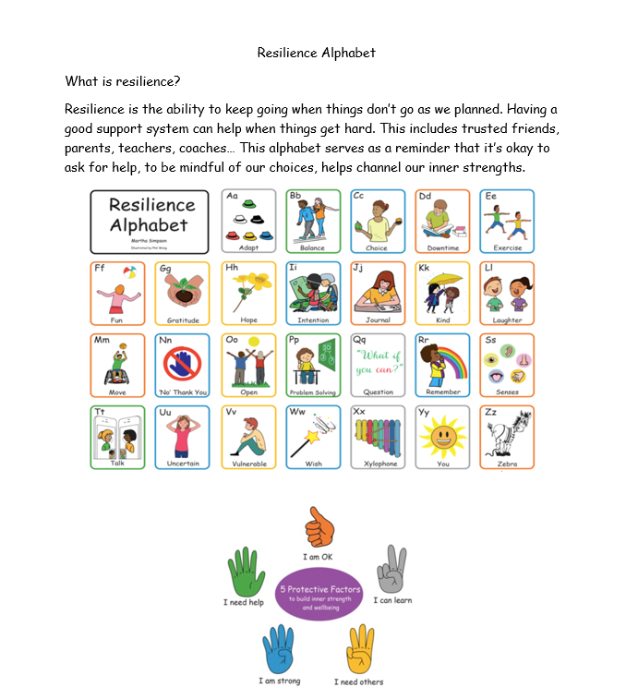

#3 - “Developing Tools for Managing Conflict”

Opening Experience
Welcome to week three of the Managing Conflict unit. Lace up your boots and strap on your belt! This week, you will be supplied with just the right tools to help you re-center, manage conflict positively and make healthy choices. The power is within you!

Activity Choices

- Choice Spinner
  - https://www.worksheetplace.com/index.php?function=DisplaySheet&sheet=Conflict-Resolution-choice-spinner&links=2&id=20591&link1=31&link2=507&cn=Conflict_Resolution
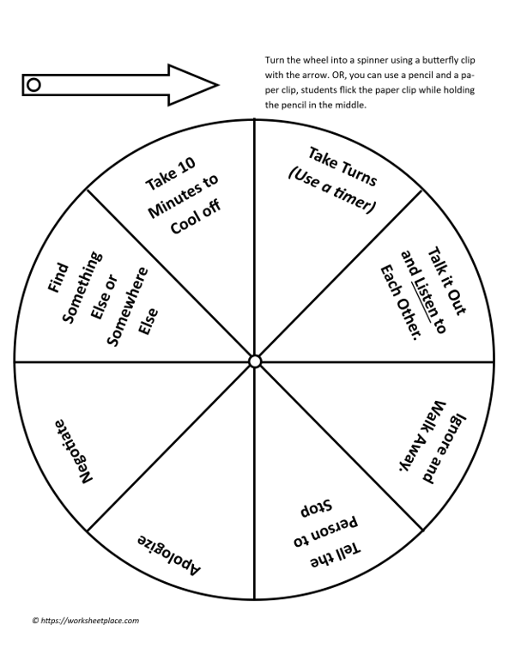

Meditation Zone
I invite you to exist in this moment with me, to close your eyes… step out of the darkness… let go of the pain… shake off the grudge… turn off the voices… and just…be. Be brave, be kind, be fearless…be unapologetically you, with God’s grace. After listening to the grounding meditation, take some time to reflect, and add a memento to your sacred space that shows how you find your inner peace.

- Grounding Meditation
https://youtu.be/q_L_DiqoRn4

- Tense and Release Muscle Relaxation
https://www.waterford.org/resources/mindfulnes-activities-for-kids/

- Problem Solving Wheel Hanout
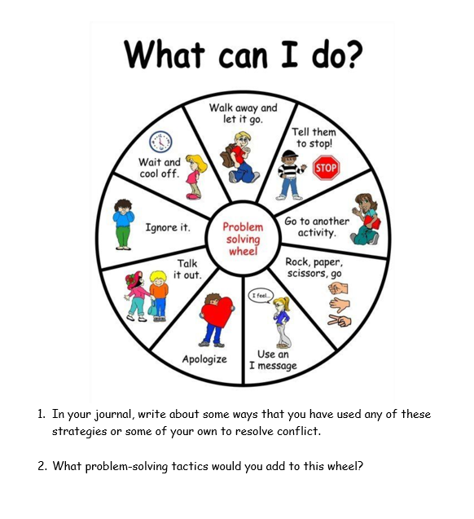
- Sacred Table Activity
Take tome time to reflect and add a memento to your sacred space that shows how you find your inner peace.

Media Room
Calm minds bring inner strength and self-confidence. Calmness comes from accepting the unplanned, and things we have little to no control over. Listen to Jayneen Sanders tell a story about how a little girl exercises her calming techniques when the world around her seems so full of chaos.

- I’m Calm by Jayneen Sanders
  - https://youtu.be/665FfQRI2z4

- Reflection Handout
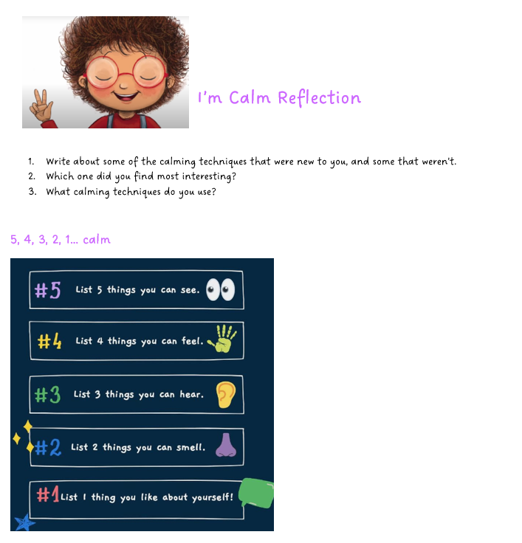

Creation Station Activities
Earlier this week, we got to put on our work boots and belt. Today, we get to take a load off and put on our dancing shoes! We’ll roll into some coping skills and boogie out with a freeze dance! Break out your best moves and get ready to groove!

- Roll a Coping Skill Handout
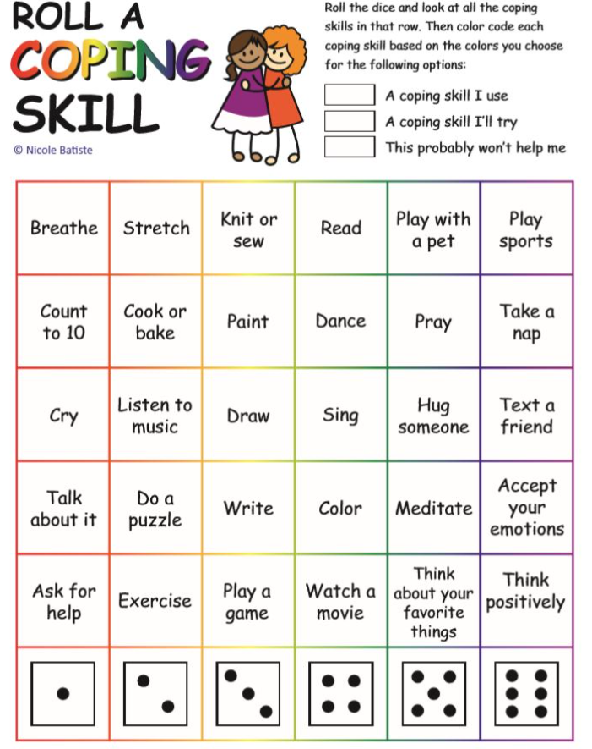
- 12 Self-Regulation Strategies (Handout)
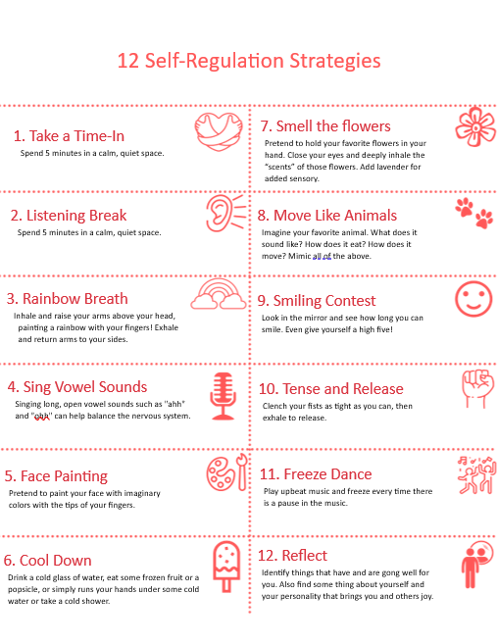

- Freeze Dance Song- The Kiboomers
  - https://youtu.be/2UcZWXvgMZE

#4 - “Being a Calm Presence.”

Opening Experience
Ahoy again! You made it to the final week of the managing conflict unit. Way to go! Next up is, going on adventures with Hunter and Eve, and using critical thinking skills to save the day on their voyages!

Activity Choices

Keeping Calm - Building Resilience with Hunter and Eve
  - https://youtu.be/losfxbMKwPo

- Solving Problems- Building Resilience with Hunter and Eve
  - https://youtu.be/Sd9MZdB1ItU

- Reflection
- How did Hunter and Eve work together to solve Hunter’s problems?
- What are the 3 steps to focus on your breathing?
- How do you think Hunter would have or could have handled his problems if Eve wasn’t there?
- If one solution doesn’t work, what should you do?
- Who is the Eve in your life? Who helps you solve problems when you can’t solve them on your own?

Meditation Zone
Do you ever feel stuck in life or with a problem? Do you get so worried or worked up that you may even feel frozen? Well, the next activity after the calming meditation is sure to melt you! What item will you add to your sacred table to reinforce thawing out any negativity?

- Calming Meditation
  - https://youtu.be/_nfx5H_7qPE

- Interactive Melting exercise
  - https://youtu.be/WxYwz23yoR4

- Sacred Table Activity:
  - Add an item to your sacred space that reminds you to breathe in moment of chaos

Media Room
Some say, “The truth can set you free”, and while that is very true, so can peace. When we are at peace within our mind and spirit, we can transfer that tranquility to the world around us.

- I Am Peace by Susan Verde
  - https://youtu.be/vnR5HDfR3JI

- Reflection Questions
When do you feel most at peace?
How do you help bring peace to others?

Creation Station
The next activities are packed with endless ideas for stimulating, self-regulating, fun. There are opportunities for coloring, doing experiments, playing games, and sensory galore. Cowabunga, explorer!

- Under the Sea Coloring Activity
https://www.allfreekidscrafts.com/Learning-Activities-for-Children/Calming-Techniques-for-Kids-Calming-Activities-for-Kids-to-Self-Sooth

- Anger Coping Word Search Handout
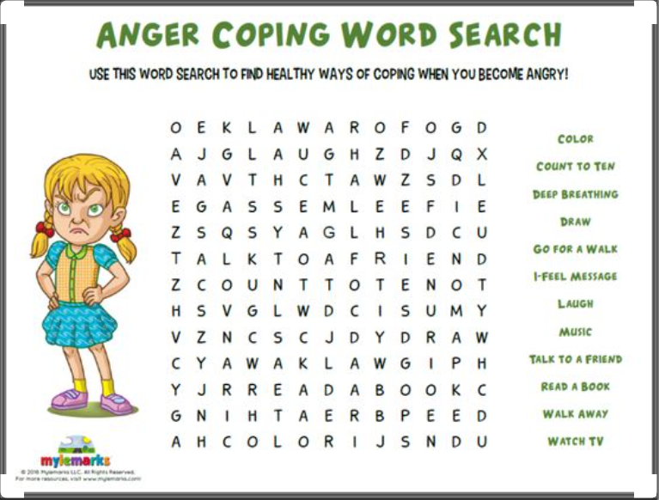

Tweens & Teens Lessons

#1 - “Recognizing Inner Conflict.”

Opening Experience
Ahoy, mate! Welcome to the first week of the Managing Conflict Unit. Let us begin this week by embracing the peace in our hearts, mind, and body. God’s love within us, gives us all the inner strength we need. Repeat these words: I am calm in moments of chaos… I am strong in the appearance of storms… I choose peace.

Activity Choices

- Emotions wheel
  - https://www.woojr.com/helping-kids-identify-emotions-worksheets/

- The Power of Not Reacting
  - https://youtu.be/iHkJjWlZhK4

Meditation Zone
Welcome to the Meditation Zone. Let’s pause and listen to this meditation that helps us manage strong emotions to reclaim a calm mind and spirit. Add a rainbow, bubbles, or an item of your choice to remind you to breathe to your sacred table.

Exploring feelings: Manage strong emotions with this meditation exercise – Flow
  - https://youtu.be/KS8p_YiolHc

- Rainbow Breathing
  - https://www.meehanmentalhealth.com/the-playful-therapist-blog/everyone-needs-a-rainbow

- Sacred Space
  - As we create our virtual sacred space, create one at home! Add a rainbow, bubbles, or an item of your choice to remind you to breathe.

Media Room
Welcome to the Media Room. Click on the red stars to hear a story about a man named Jerry, who radiates positivity throughout New York City, and has changed the lives of many. Reflect on your own character, and what kind of attitude and energy you spread.

- The Story of Jerry
    - https://youtu.be/7gM0f0ifGfI

- Reflection
- Why did waitresses quit their jobs?
- How does Jerry stay so positive?
- What went through Jerry’s mind during the robbery?
- How would you respond in that situation?
- Write about ways you keep a positive mindset.

Creation Station
Aloha from the creativity station! Grab your art supplies, because this week, we’ll explore our Feelings with creative and colorful paintings, followed up with a fun emotions dice game. Remember that no emotion is bad to have. Everything that you feel is valid and okay. It’s how we express those emotions that matter. Writing them down or talking them out when you’re feeling them is healthy and helpful.

- Emotions Painting
  - https://kinderart.com/art-lessons/painting/emotion/

By recognizing your feelings, you are managing conflict and bringing peace to your heart, mind, and body.

- What are some daily emotions that you experience?
- What came to mind while painting your emotions?
- Write about a style of music that helps you cope with these feelings and why this genre.

- Emotions Dice Set
  - https://www.andnextcomesl.com/2019/04/free-printable-emotions-dice-game.html

- Prepare the dice and read the different feelings that are on it. Describe what these mean to you.
- Share an experience when this feeling had come up and what you were doing.
- This could be about an experience that was bad and made you feel bad.
- Take turns rolling the dice and answer the question that is on the side.
- If the feeling was “Worry” you could say that your body and mind are overstressed and need to wind down.
- Explain how recognizing your feelings leads to managing conflict.
- Know that when you recognize your feelings you manage conflict and have peace in your heart, mind, body.

#2 - “Finding Inner Strength.”

Opening Experience
Welcome back to the second week of the managing conflict unit. We will dive deeper into self-awareness and honing your inner strength with a motivational video by David Goggins, and then indulge in some positive self-reflecting with a strengths challenge.

Activity Choices

Learn the Power of Failure | Find Your Inner Strength - David Goggins
  - https://youtu.be/ov8-l8NZnbU

- Strengths Reflection Handout
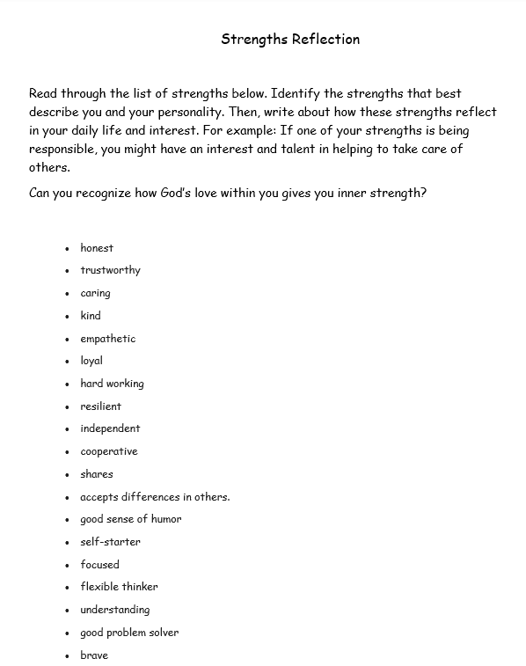

Meditation Zone
Enjoy this inner strengths mediation by Beth Kurland and then, add to your sacred space with an item that represents or is a reminder to practice exercising daily mindfulness.

- Meditation for Inner Strength by Beth Kurland
  - https://youtu.be/zuw3fiSG6mQ

- Thought Counting
  - https://www.momjunction.com/articles/meditation-techniques-for-teens_00330301/
  - Write about some of the ways that teens especially may benefit from meditation.

Media Room
If try, try, try again were a person, it would be Colonel Sanders. He came from a broken household, developed business plans that fell through the cracks, lost all his money, and was rejected literally a thousand times before finally becoming successful. At the age of 75, Colonel Sanders’s perseverance paid off, and he was recognized for his life’s dream of what we now know as Kentucky Fried Chicken! So, no matter how hard things get, or downhill they seem to be going… try, try, and try again.

- He Failed a Thousand Times (A story about not giving up based on the life story of Colonel Sanders)
https://youtu.be/Dbb4htY9ldw

- Reflection
  - What parts of this story can you relate to?
  - What are some of your roles of responsibility in your everyday life?
  - Reflect on some failures you’ve experienced. Did you give up or come up with a different way to achieve your goal?

Creation Station
If you could talk to your future self, what do you think the future you would have to say about today you? Would you be proud of future you? Would future you be proud of the choices you make today? This week, we’ll put our imaginations to work, by writing a letter to our future selves.

- Letter to Myself Handout
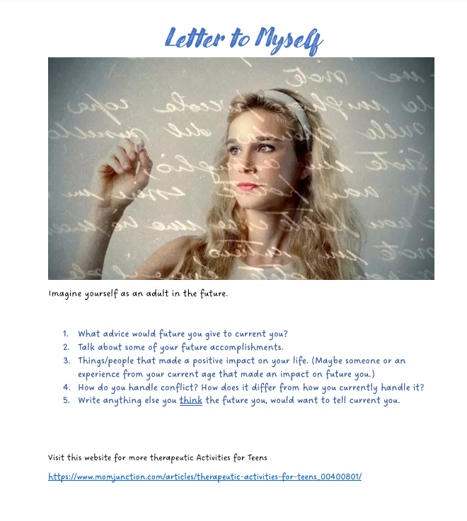

#3 - “Developing Tools to Manage Conflict”

Opening Experience
Welcome to week three of the Managing Conflict unit. Lace-up your boots and strap on your belt! This week, you will be supplied with just the right tools to help you manage conflict positively and make healthy choices. The power is within you!

Activity Choices

- Conflict Resolution Skills
  - https://www.helpguide.org/articles/relationships-communication/conflict-resolution-skills.htm

- Reflection
  - Define conflict in your own words.
  - How do you respond to conflict?
  - What are some examples of causes of conflicts in relationships? (This can be relationships with siblings, friends, parents, authority figures…)
  - What key conflict management skills did you take away from this article?

Heartbeat: A Mindfulness Exercise to Calm Your Emotions
  - https://youtu.be/3iUf73v92lI

Meditation Zone
I invite you to exist in this moment with me, to close your eyes… step out of the darkness… let go of the pain… shake off the grudge… turn off the voices… and just…be. Be brave, be kind, be fearless…be unapologetically you, with God’s grace. After practicing your breathing with the guided meditation, take some time to reflect, and add a memento to your sacred space that shows how you find your inner peace.

- Guided Breathing Meditation
  - https://youtu.be/DbDoBzGY3vo

- Take a Breather! Box Breathing Activity
  - https://youtu.be/tqqe9lbgVRk
- Mindful Word
  - https://positivepsychology.com/mindfulness-for-kids/
- Sacred Space
  - Add a memento to your sacred space that represents how you find your inner peace.

Media Room
Calm minds bring inner strength and self-confidence. Calmness comes from accepting the unplanned, and things we have little to no control over. Learn coping techniques for anxiety, and how to recenter your calm with a mindful approach story by Gabi Garcia.

- Find Your Calm by Gabi Garcia
https://youtu.be/Z4UMjjO1084

- Reflection Questions
  - How do you feel when you are accepted?
  - What do you think the calling is that God has for you?
  - How can you use your senses to help you feel calm?

Creation Station
You being at peace with yourself greatly benefits the way in which you resolve conflict. When you go into conflict with a positive attitude, it’s easier to come out of it with positivity. Your accountability, self-actualization, self-reflection, and the way you talk to yourself, all play a role in your attitude toward self, others, and your ability to resolve conflict and be resilient.

- Positive Self-Talk Changer
  - https://copingskillsforkids.com/teens

- Conflict Resolution Bingo
  - https://bingobaker.com/view/3950142

- 12 Self-Regulation Strategies Handout
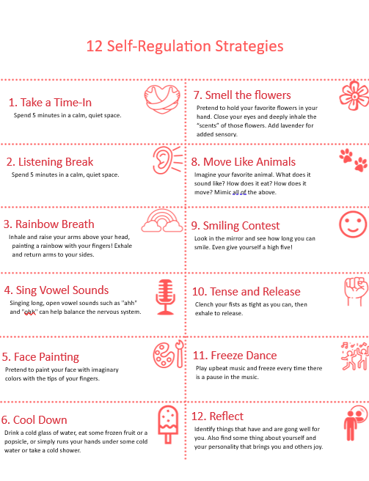

#4 - “Being a Calm Presence.”

Opening Experience
Ahoy again! You made it to the final week of the managing conflict unit. Way to go! Next up is, a power voyage. Explore Unity’s 12 Powers, and how each one plays a role in helping to resolve and manage conflict. But wait, there’s more! We get to break out the art supplies again. Make a sun craft to hang as a reflection of life and light, and that you can choose peace at any time.

Activity Choices

- Unity 12 Powers
  - https://www.unity.org/collection/unity-12-powers
  - Give one example (or more if you choose), of how each of the 12 powers plays a role in helping to resolve conflict. Example: Love- I am the center of love. When in conflict, I remember to love thy neighbor and choose to love them, even if I disagree with them.

- Coffee Filter Sun Craft
  - https://www.busymommymedia.com/coffee-filter-sun-craft/

  - The sun is a reflection of life and light. Our presence is like this as it connects us to the life and light that is within us.
  - When we are aware, we feel life and the light of our divinity encompassing us.
  - Being aware of the life and the light as presence, you are a calm presence. We choose joy and optimism in every experience.
  - Display your art as a reminder that you can choose peace at any time and be healthy.

Meditation Zone
Your headspace is another one of those things that can help shape the way you respond to conflict. How do you practice self-care and mindfulness? Join me in this mini meditation to practice our breathing, for a clear headspace. Feel free to listen to it as many times as you want or need. Add a symbol of something that represents a clear headspace or being at peace to your sacred space.

- Headspace/Mini Meditation
  - https://youtu.be/cEqZthCaMpo

Reflection
- As you inhale, think of the feeling that peace evokes. Bring this feeling of peace to your toes and up through your head. Imagine what peace looks like by remembering experiences that brought calmness.
- Exhaling with the word “love” think of what it would be like to have this feeling of peace every day.

- Peace Love Meditation
  - https://www.kidsyogastories.com/peace-love-meditation/

- Sacred Table
  - Add a symbol of something that represents a clear head space or being at peace to your sacred space.

Media Room
Some say, “The truth can set you free”, and whilst that is very true, so can peace. When we are at peace within our mind and spirit, we can transfer that tranquility to the world around us.

- I’m Calm/Jayneen Sanders
  - https://youtu.be/665FfQRI2z4

- Reflection
  - Write about some times that you have experienced “chocking.”
  - What can you do to help reduce the chance of choking under pressure?

Creation Station
The next activities are packed with endless ideas for stimulating self-regulation and reflection. All for the benefit of being at peace and resolving conflict in a Christlike manner. Cowabunga, explorer!

- Emotions Portrait
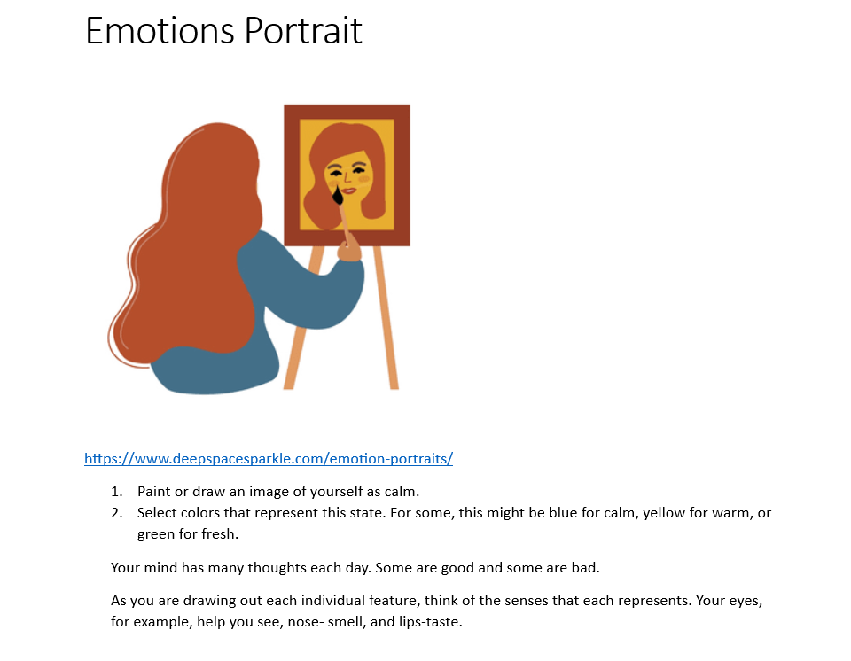

- Calming Strategies for Teens
  - Put together a blueprint of your idea of a community that is open to all.
https://gozen.com/8-calm-down-strategies-for-your-teen/

Conflict Resolution: How to Settle Your Differences Fairly | Brain POP
https://youtu.be/jg_Q34kGsKg

