  - Belonging Unit

Unit Overview
Unit Focus:
The intention of this unit is to promote healthy relationships in the community, encourage positive self-reflection and discovery, and implement practices for a sense of belonging.

Unit Outcomes: By the end of the Unit learners will be able to:
- Self-reflect in a positive loving way to promote self-growth and accountability.
- Know how to connect with others while expressing loving kindness safely.
- Gain a better sense of self, the importance of honesty, and our responsibility to ourselves, others, and the world in which we live.
Unit Weekly Themes:
- To What Am I Connected
- How Do I Engage with Others?
- Trust and Loving Kindness
- What is Our Responsibility to Each Other?

Affirmations
- Every beat of my heart radiates the harmonizing power of divine love. Every beat of my heart radiates the harmonizing power of divine love.
- I breathe into the healing power of God, the renewing pulse in my body, mind, and spirit.
- Celebrating unexpected blessings, I live well today.
- One with God and one with all, I am a peaceful presence.

Bible Quotes

Let the peace of Christ rule in your hearts, since as members of one body you were called to peace. And be thankful. Colossians 3:15

Rejoice always, pray without ceasing, give thanks in all circumstances; for this is the will of God in Christ Jesus for you. 1 Thessalonians 5:16–18
- Give thanks to the Lord, for he is good; his love endures forever.1 Chronicles 16:34
- Every good and perfect gift is from above, coming down from the Father of the heavenly lights, who does not change like shifting shadows. James 1:17

Unity/Fillmore Quotes
- Charles Fillmore: “I fairly sizzle with zeal, energy, and enthusiasm; eager to do that which ought to be done by me today.”
- Charles Fillmore: “Words are also seeds, and when dropped into the invisible spiritual substance, they grow and bring forth after their kind.”
- Daily Word 1930: “At one with God, I am at one with all good, Universal good,
all the good that there is.”
- Myrtle Fillmore: “Keep on praying for faith, it is through prayer that you develop all your wonderful qualities of soul.

Children’s Lessons

#1 - To What Am I Connected?

Opening Experience
Welcome to our first unit on “Belonging.”

Welcome to the first week of the Belonging unit! Let’s get connected with ourselves, each other, and the world around us. We’ll do some self-reflecting, explore by making art out of food, and so many other exciting activities this week. Have fun!

Activity Choices

I Am Enough by Grace Byers Read Aloud
  - https://youtu.be/hRFI-N4kYZk

- Self-Regulation Strategies and Games
  - https://www.mylemarks.com/store/c36/FREE_DOWNLOADS.html

- We Belong- A Song For Little Learners About Inclusion and Belonging
  - https://youtu.be/WO-WTpAP-6g

Meditation Zone
Welcome to the meditation room! Find a quiet, comfy spot, and a position that feels most comfortable for you. This is a time for you to just relax and embrace the naturally awesome, and beautiful you. That’s right boys, even you, are beautiful, just as God created you, inside and out! After you’ve had some time to meditate, we’ll get on our feet and practice shaking off any icky feelings to be the best you, that you can be.

Activity Choices

- Belonging- A Guided Meditation
  - https://youtu.be/7XbjOODC57o

7-Minute Emotion Regulating Activity to Help Kids Calm Down! (with mindful breathing techniques)

https://youtu.be/ORRdf_nLc_I

- Mindset Growth (Handout)
  - 10 Mindset Growth Questions to Ask Yourself

- Sacred Table Activity:
  - Start your sacred space with a candle, to remind you of the Christ Light within you.

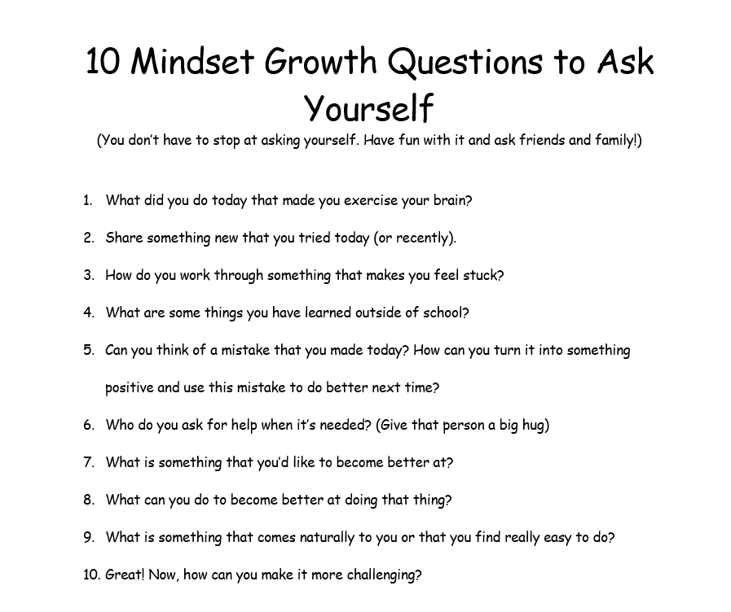

Media Room
Time to do some reflecting. Literally! Grab your journal, some popcorn, and kick back to watch a short clip, on self-love, acceptance, and a positive self-image. The power of our own Divinity is what releases our innate potential and transforms us.

Today we will watch the video:
- The Reflection in Me https://www.youtube.com/watch?v=D9OOXCu5XMg

Reflection Questions
- What was your favorite affirmation from this video? Were there any that you really connected with?
- Write 3 affirmations for yourself and put them somewhere you can reflect on them daily. Ask an adult if you need help coming up with some ideas.
- What are some of your favorite things about you?
- Describe yourself in 3 words.
- Reflect on the words you used to describe yourself…How do they make you feel looking back on them?
- What (or who) makes you feel loved?

Creation Station Activities
What’s cookin good lookin? Nothing much said the punch! This week, with an adult’s help, we’ll take our creativity to the kitchen! First, watch the story I am Human By Susan Verde, and then make your own delicious food human with an adult’s permission.

- I am Human Read Aloud:
  - https://youtu.be/0JpquUi58TY

- Food Human Handout:
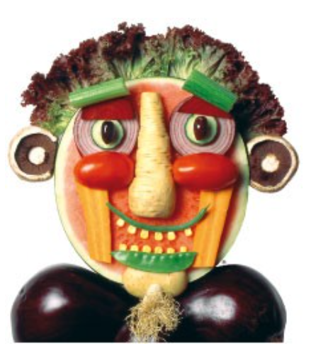

Have a parent or other adult help you gather some delicious supplies to make a self-portrait or just a funny face. Do you have red hair? Use orange or strawberry slices! Food is just one example of items that can be used to do this activity, but the sky (or in this case, your roof) is the limit! You can use construction paper, cardboard, Q tips… Just be sure that no matter what you’re using, you have adult permission and most importantly, that you’re having fun!

#2 - “How Do I Engage with Others?”

Opening Experience
Welcome to week 2 of Belonging. Now that we’ve practiced ways of identifying with and connecting to ourselves, we will begin our adventure of connecting with others. Remember, there is only one you and only one me, but we are both and all, only human. As humans, it is natural to desire relationships of various levels and connections with others. We will begin our journey with a creative, kid- lead video on tips for making new friends and then dive into some other fun activities to discover connecting with others, different and alike.

Activity Choices
- Kid President's Guide to Making a New Friend
  - https://youtu.be/OoHdwUEfBts

- All About Social Skills for Kids
  - https://youtu.be/Myf2CUx9E60

- Put It into Practice (Reflection)
  - How can you practice active listening?
  - What are some examples of social cues?
  - How can you help improve your social skills?
  - Who can you practice social skills with?

Meditation Zone
We’ve connected with ourselves and others, now let’s connect with the world around us. Before we start our meditation, step outside, or open a window and take a moment just to breathe and appreciate the world around us. This mindful meditation will show you how to connect even deeper with everything around you, followed by peaceful nature activities.

- Guided Meditation for Feeling a Deep Connection to Everything
  - https://youtu.be/0FR0r0yaG6s

- Connecting With Nature
  - https://pbskids.org/daniel/games/nature-walk

- 30 Days of Nature (Handout)
  - Exploring nature is another way of therapeutically connecting with others.

- Sacred Table Activity
  - Add an item to your sacred space, from one of your nature activities as a reminder to pause and enjoy the naturally simple, and beautiful moments in life.

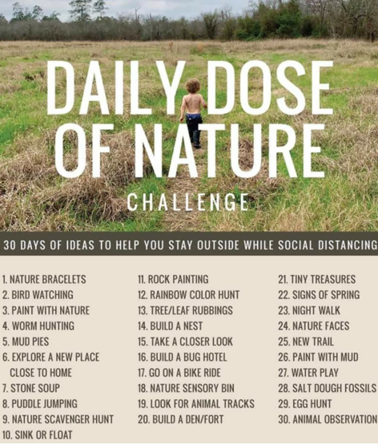

Media Room
Sometimes, a connection is silent. It can be done through a random act of kindness, a split moment of bravery, or a hug. Actions can speak louder than words, though a simple word of kindness or encouragement can go a long way. This week’s short film is about a young girl whose integrity and small act of kindness gave great hope to a fellow classmate that she didn’t even know.

- Are You Okay- Short Film
  - https://youtu.be/tJsGGsPNakw

- Reflection Questions
  - What would you do if you saw someone else being bullied?
  - Do think there was more that Raquel could or should have done to help Noah?
  - How would you have helped Noah?
  - How do you think Raquel asking Noah “Are you okay” made him feel?
  - Who is someone that you could talk to about being bullied?

Creation Station Activities
Welcome to the creativity station! Now that we’ve practiced building our social skills let’s discover where we can best put them into action and why being social with others is so good for us!

- Building Social Connections
  - https://youtu.be/8az-gfljEbg

- Reflection Questions
  - How can connecting with others help your health?
  - What are some things you can do in your community to connect with others?
  - Share about some group activities that you are a part of (church, sports, robotics, band…).
  - What is something you could do this week to help others?

- PBS Social Skills (Select a Social Skills Game Based on Your Age)
  - https://www.pbs.org/parents/learn-grow/all-ages/social-skills

#3 - “Trust and Loving Kindness”

Opening Experience
Being Kind and social is a good thing to do, but it's important to always be safe when doing so. This week, we'll look at who to trust and how we can build connections with loving kindness and boundaries.

Activity Choices
- Rules for Protecting Yourself-
  - https://youtu.be/SY7RhBszp0k

- Reflection Questions
  - What could have happened if Sarah and Lenny went with the dog owner?
  - What are some ways people might try to trick you into coming with them?
  - Should you ever be alone or go with someone you don’t know?
  - If someone that you don’t know ask for your help or for

- Stranger Danger (Handout)

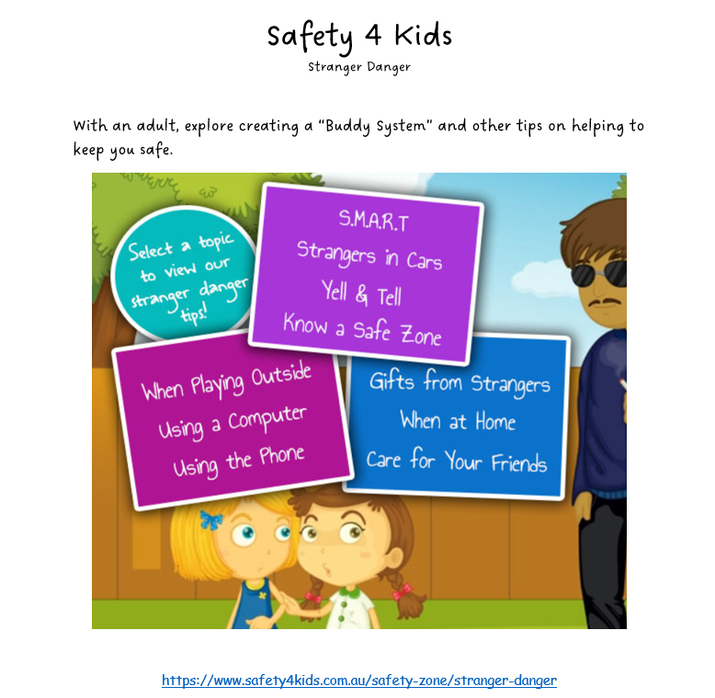

Meditation Zone
Oh, how true it is that love and kindness make the world go round… or at least a better place anyway. This meditation is sure to fill your body with warm, fuzzy thoughts of love and kindness. Hang on to those ideals! You’ll need them for the next activity. Now, deep breaths, relax, and get ready to be filled with love!

- Loving Kindness Meditation
  - https://youtu.be/8p0ztXGN9zE

- Kids Describe Love to an Illustrator
  - https://youtu.be/I0_T-Sb-Loc

- Draw your own picture and or write about:
  - What love means to you.
  - The things, people, places, and animals that you love.

- Sacred Table Activity
  - Add an item to your sacred space that reminds you of the love that you hold to give to others, and those who you hold closest in your heart.

Media Room
Trust… such a small word with a BIG meaning. It’s important to feel safe and know that we can trust those around us, but we must also do our part and be trustworthy. Watch a short clip on what it means to be trustworthy, what happens when trust is broken, and the power of telling the truth. Then, grab your journal to share your thoughts on trust.

- Honesty is My Superpower Read Aloud
  - https://youtu.be/3Z-Ads5yRAs

- Reflection Questions
- Why didn’t Nao believe Tommy when Tommy said he’d lost the key to his treasure box?
- Why do you think Nao & Tommy’s mom wasn’t upset when Nao said he made the mess?
- What does the “T” sign mean in this story?
- What helps you to not tell lies?
- What does it mean to you to be trustworthy?

Creation Station Activities
With the help of an adult, grab some art supplies and pass on the goodness of your heart! This week, we’re really getting creative with games and crafts of kindness.

- The Science of Kindness
  - https://youtu.be/O9UByLyOjBM

- Random Acts of Kindness Bingo (Handout)

- STEM Kindness Extravaganza- Kindness Chain Challenge
  - https://youtu.be/p02ymwgLKzg
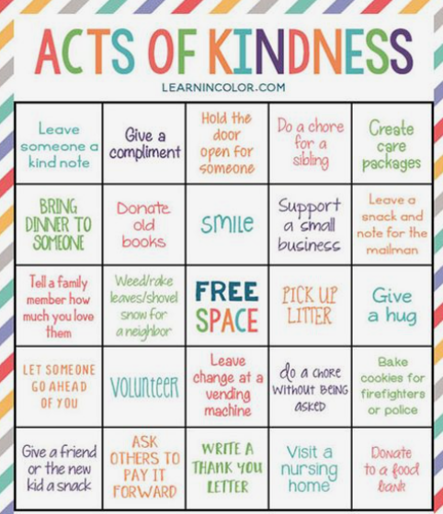

#4 - “What Is Our Responsibility to Each Other?”

Opening Experience
Welcome to the final week of Belonging! Phew! Have we been busy! We’ve learned about connecting with ourselves and others, practicing safety first, spreading love and kindness, and what it looks like to be trustworthy. Now, we’ll take a look into what it means to be responsible, who and what we’re responsible for, and the natural consequences that occur when we aren’t responsible.

Activity Choices

Responsibility For Kids | I Am Responsible For Me | Social and Emotional Learning for Kids (Part 1)
  - https://youtu.be/SFvZtDqFYU4

- Reflection Questions
  - Who are you responsible for?
  - Who was responsible for Cam not being able to go to his friend’s house?
  - What should you do when you “mess up”?

Meditation Zone
You’ll need your eyes open for this mediation, to read the responsibility affirmations on the screen, but still, settle in and get comfy! This meditation reflects on the most essential but often forgotten responsibility…being our true selves.

- Personal Responsibility Meditation
  - https://youtu.be/MITrytmD06E

- Family Service Projects (Handout)

- Mathew West- Do Something
  - https://youtu.be/b_RjndG0IX8

- Sacred Table Activity:
  - Add an item that represents a time when you were most proud of yourself for a good or responsible choice that you made.

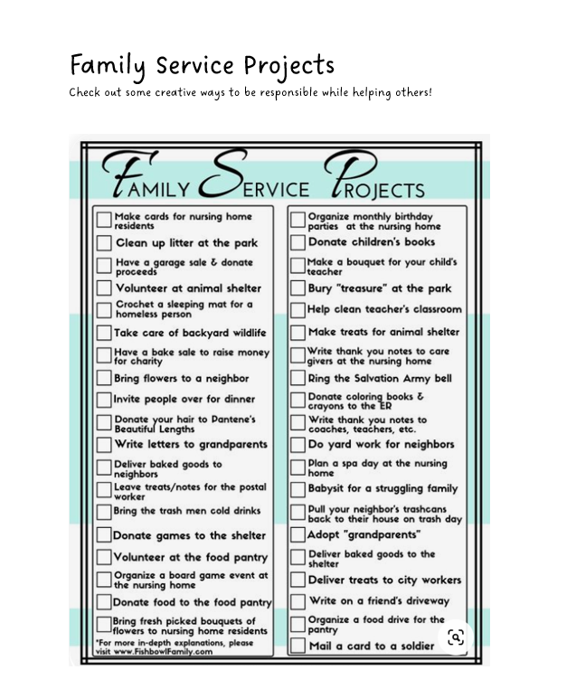

Media Room
Greetings back to the media room! Sometimes, doing a good deed goes unnoticed, and that’s okay. Although being rewarded is nice, being responsible, trustworthy, and kind should be done from the heart, without the expectation of being rewarded. Though we are not responsible for anyone else’s feelings, a small gesture of kindness can make all the difference. Smiles are contagious, so go spread some!
- Snack Attack
  - https://youtu.be/38y_1EWIE9I

- Reflection Questions
  - How do you think the woman could have handled the situation differently?
  - How would you respond if you thought someone was taking something from you?
  - How do you think the woman felt when she realized those weren’t her cookies?
  - What do you think the boy thought of the woman?
  - What did you take away from this video?

Creation Station
Soooo, who’s responsible for whom, and what am I really responsible for? I’m so glad you asked! These next activities will answer just that! We are responsible for yes, ourselves first. We are also responsible for playing our role the best that we can as students, siblings, children to our parents, members of a team, and members of our churches. We are also responsible for helping to take care of the planet that we live on! But I bet brilliant you, already thought of that. Let’s dig in!

- All About Family Roles
  - https://youtu.be/gwXKtM0N-EY

- Reflection
  - What roles do you play?
  - How can you make sure you are the best you that you can be in your role(s)? Are you a team player?

- How to take Care of The Environment
  - https://youtu.be/X2YgM1Zw4_E

- Reflection Questions
  - How can you help save energy?
  - How can you help save water?
  - What are some other ways that you are responsible for helping to take care of our environment?

- Save the Planet Song
  - https://youtu.be/lJToF8D9bdU

Tweens & Teens Lessons

#1 - “What Do I Believe About Myself?”

Opening Experience
Welcome to our first week of the belonging unit. Let’s define belonging in a way that connects with our true identity. "I Am one with All and All in me. God is my Identity, and this unites me with all.

Activity Choices
- Belonging By Kevin Carroll
  - https://youtu.be/D61RKIvcDJk

- My Definition of Belonging (Handout)

- Reflection Questions
- Think about a time when you experienced a sense of belonging in a group. How did you know you belonged?
- Think about a time when you struggled to feel that you belonged in a group. What happened?
- Think about a time you witnessed someone else struggle to feel that they belonged in a group. What happened?

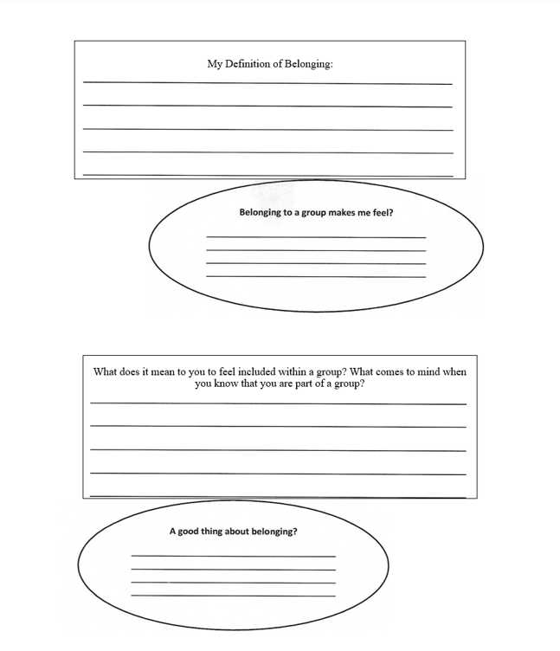

Meditation Zone
Create a sacred space before you begin the meditation. As we create our virtual Sacred Table, create one at home! Place an object that represents who you are and repeat the words “I belong” to yourself several times. “Your sacred place is where you can find yourself again, and again”. – Joseph Campbell

- A Belonging Guided Meditation
  - https://youtu.be/7XbjOODC57o

Media Room
Grab your journal, and some popcorn, and kick back to watch a short clip on what happens when one person is searching for a place to be a part of and belong. Then reflect on the situation and share some of your own experiences.
- Belonging- A Short Film
    - https://youtu.be/ZgT-GQvwZ9k
- Ask Yourself:
  - Who am I?
  - How do I see myself?
  - What comes to mind when I read this scripture: The earth is the Lord’s, and all it contains; The world, and those who dwell in it. Psalm 24:1
  - How do I connect with the “truth” of who I am to God?

Creation Station
Welcome to the Creativity Station. First, listen to a song that opens up your heart and mind to see yourself where you do belong, and that you do belong… Then, create a “Belonging Soul Book.” A book just for you, all about you. Have fun!

- Kevin Quinn - Where I belong
  - https://youtu.be/tiR-eCHEG8I

  - After watching and listening to the song video, create a Belonging Soul Book. Get any notebook, journal, or booklet and in it, each page creates a page that represents who you are, what you like, and all of your thoughts as the days go by.. create that page with art, magazine clips, writings, poems, etc… whatever represents you.

#2 - “How Do I Engage With Others?”

Opening Experience
Welcome back to the Belonging Unit. In week two we will take a deeper look into healthy relations and Unity Principles 1 & 2. They are a great guide to seeing both yourself and others as a reality of who we all are. “I am divine” means we are all divine, so we belong, and are open to the truth of one in all.

Activity Choices
- Healthy Relationships
  - https://youtu.be/Gn7ZQ2x0cOE

- Reflection Questions
  - What qualities are found in a healthy relationship?
  - How is Unity Principle 2 a guide to living a healthy relationship when it comes to belonging?

Meditation Zone
Join us in an open-eyed video meditation experience, “We Are Unity”. Take a deep breath, relax inward into your heart space, and put your hands over your heart. As you watch the video, breathe regularly in and out, and visualize this message reaching that space of the Divine within you, and settling there for Good.

- We Are Unity
  - https://youtu.be/3BS_apbK7L0

- Sacred Table
  - In your sacred space place a picture of you over a picture of the earth. Use these two images to connect your heart while this song is playing…

Media Room
There is only one you and only one me, but we are both and all, only human. As humans, it is natural to desire relationships of various levels and connections with others. Listen to the song “All We Are” and think how this is a call to connect with everyone around us.

- Richello All We Are
  - https://youtu.be/cSL6-9ZkIHk

- Belonging Bulletin
- Find Belonging quotes and create a collage with them. Put them around your room to wake up in the morning.

- Become a reporter and go around asking different people of all ages their idea of Belonging. Write them down and create a section in your journal with the quotes that best connect with your ideas on belonging.

- Journal time with the following questions for self-activity on belonging:

  - What does it take to be a part of each other?
  - How do you show others that you accept them?

  - How do you open up and let God be among you?

Creation Station
When we see each other's True Colors we can build a bridge that gives us a sense of belonging. Listen to the “True Colors” cover song, about how we are always enough, and that all is within us.

- True Colors
  - https://youtu.be/cQ7off9fdS4

- Medicine Wheel (Handout)
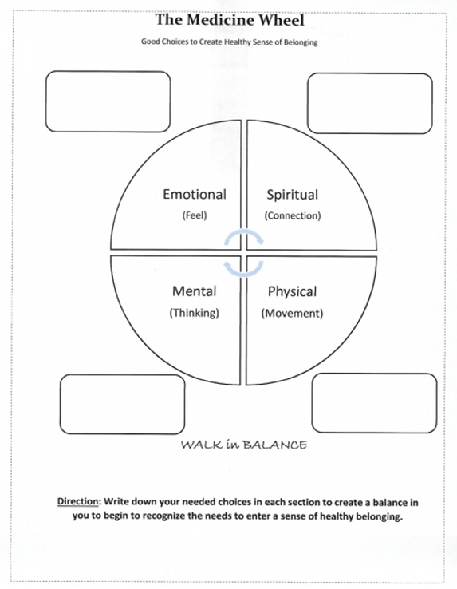

#3 - “Trust and Loving Kindness”

Opening Experience
Now that we’ve practiced ways of identifying with and connecting to ourselves, we will begin our adventure of connecting with others. This week, we will look at whom to trust, and how we can build connections with love and kindness with boundaries. Lastly, practice implementing Unity’s Principle #3 into your journey of spiritual growth. Principle #3 quotes- how my thoughts and prayers are formative in creating the life I live. What I believe at my core colors my experiences and interactions, and ultimately provides the tone of my life. I want the best life I can live, and connect with others in wonderful healthy relationships.

Activity Choices
- What does this line from Charles Fillmore mean to you: “Beloved, let us love one another: for love is of God and everyone that love is begotten of God” Christian Healing p139

- Read Unity Principle # 3 “We are co-creators with God, creating reality through thoughts held in mind.” Or “I create my experiences by what I choose to think and what I feel and believe.” Reflect on how this principle challenges you to embrace others and begin to belong. Write 5 truths about belonging that are positive and you bring into that relationship.

- Purl- Pixar SparkShorts
  - https://youtu.be/B6uuIHpFkuo

- Reflection Questions
  - Why is it so important to be kind to others?
  - How does kindness create a sense of belonging?
  - Create a section in your journal called “Random Acts of Kindness”. Write down the act of kindness that you do throughout the week.
  - How does kindness create a strong bond to God’s love?

Meditation Zone
Oh, how true it is that love and kindness make the world go round… or at least a better place anyway. Kamani's meditation poem will surely fill your body with warm, fuzzy thoughts of love and kindness.

- Fireflies by Michele McLaughlin
  - https://youtu.be/01q5YCwn-Cw

- Sacred Table
  - Create a heart out of clay, (play-doh or fast Air-Drying Clay) and place it in your sacred space before you begin the meditation with the “Belonging” poem.

Media Room
You may have heard the saying "always do the right thing, even when no one is looking". Well, it is equally important to always be you, even if everyone is looking. Embrace the naturally awesome, and talented you. You are beautiful, just as God created you, inside and out!

- Inclusion Makes the World More Vibrant
  - https://youtu.be/QXY5TyCUTlo

- Reflection Questions
  - How do you feel when you are accepted?
  - What do you think the calling is that God has for you?

Creation Station
Aloha, from the creativity station! Are you ready to get creative? …….. Great! We are going to dive into a fun project that you can share with your community. They’re going to love it!

- Belonging Wall Graphic
  - Create a poster board with your own Belonging Graphic wall design. After you design it use different colors and then reflect on what it means to you.
  - Take Your Graphic Wall Design and share with others. See if you can present it to your community and see if you can design it and share it in the community.

- 3 Good Things
  - According to Fredrickson’s broaden-and-build theory (2001), positive emotions can help broaden your momentary thoughts, actions, and attention to your surroundings. One example of this is to foster positive thoughts and emotions. Says Barbara Fredrickson, PhD, the author of Positivity (2009): “In our research program, we found that the daily repertoire of emotions of people who are highly resilient is remarkably different from those who are not.”
    - Consider ending your day by reflecting on and writing down 3 good things that happened today.
    - Be intentional about reflecting on the experiences, noting how you felt, and what was the best thing about the experience.

- A Story About Emotions
  - https://youtu.be/SJOjpprbfeE

- Let Your Emotions Out
  - It is important that you let the emotions flow. Letting negative emotions build up can be critical because an excess of these emotions will lead you towards a negative mindset. When you feel that negative emotions are building within, divert all the negative energy towards an emotional outlet, which could be a number of things—swimming, running, boxing, or anything.

#4 - “Connecting With Me”

Opening Experience
Welcome to the final week of Belonging! This week leads us to Principle #5 – action! Where does all this take me? How will I choose to show up, and when I do, what will I create? From how I relate to others to how I can serve; we will move to ways we can live life as a declaration of our Divine nature.

Activity Choices

- How to Know Yourself
  - https://youtu.be/4lTbWQ8zD3w

- Self-Exploration
  - https://paradigmtreatment.com/self-exploration-teen-questionaire/

- 80 Self Care Activities for Teens
  - https://www.kiddiematters.com/80-self-care-activities-teens/

Meditation Zone
This meditation is about finding the sacred within yourself, your center, and your peaceful core. We each have a sacred space within us, a part of us. This sacred space is a temple, a temple to our inner power, our intuition, and our connection with the divine.

- Grounding Techniques (Handout)

- 5 Minute Energy Grounding & Cleansing Meditation
  - https://youtu.be/9GWnQXVEiJM
- Reflection
  - After meditating, write in your journal some insights on where you see yourself.
  - Where are you in your search for belonging?
  - Why is trust so important for belonging?
  - Create your ideal setting for the power of belonging.

- Sacred Space
  - Place a White Candle in the middle of the room. Take some textured fabric in place it around the sacred area.
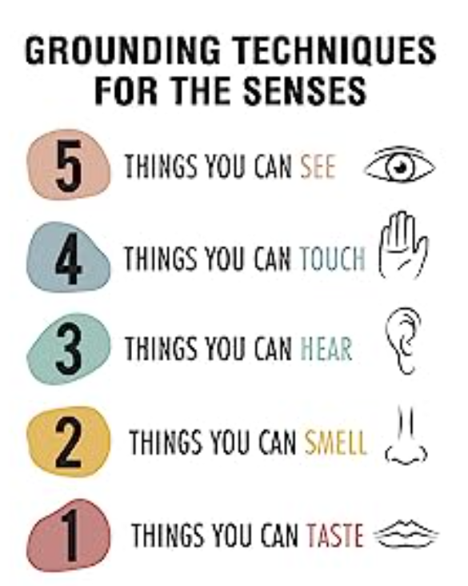

Media Room
Greetings back to the media room! We will be exploring some biblical characters for motivation ad reflecting on the power of creating a sense of belonging. Get ready for a blast from the past!

- Say Something
  - https://youtu.be/otxjBXEEqUk

- Reflection
  - “Those who have a strong sense of belonging have the courage to be imperfect.”-Brene Brown
  - Write in your journal what you think that quote means. Try to think of some personal examples.

Creation Station
Welcome to the final week of the belonging Unit. Use the two handouts “Belonging Discussion Prompts” and “Belonging Reflection”, to begin putting faith into action when others are searching for the right place to be involved in.

- Self-Reflecting
  - What are some times when or places where you feel that you belong?
  - What are some times/places where some may feel that they don’t belong?
  - What are some ways that you can help others feel included?

- Community Blueprint
  - Put together a blueprint of your idea of a community that is open to all.
  - What are the essential things that is needed to create a “kingdom of God”?

- Linkin Park- One More Night
  - https://youtu.be/t97rfv12bdw

