  - Self-Responsibility

Unit Overview
Unit Focus:
This unit focuses on what it means to be accountable to both our words and our actions and to recognize how our choices affect ourselves and others.

Unit Outcomes: By the end of the Unit learners will be able to:
- Recognize those things that are not good for us and develop a plan to release them
- Develop tools to see things in a new way
- Take responsibility for their choices
- Recognize the beauty in everything and looking for the good

Unit Weekly Themes:
- Being Accountable
- Making Choices
- Seeing Things in a New Way
- Activating Hope

Affirmations
- Each choice I make is made in partnership with God.
- I let God show me a better way in everything I do and say.
- I am responsible for my feelings and actions, and I choose them wisely.
- I am hopeful and optimistic about my life.

Bible Quotes
- So then, each of us will give an account of ourselves to God. Romans 14:12

- For God hath not given us the spirit of fear; but of power, and of love, and of a sound mind. 2 Timothy 1:7

- And he answering said, Thou shalt love the Lord thy God with all thy heart, and with all thy soul, and with all thy strength, and with all thy mind; and thy neighbor as thyself. Luke 10:27

- Arise; for this matter belongs to you: we also will be with you: be of good courage, and do it. Ezra 10:4

Unity/Fillmore Quotes
Teach Us to Pray p73
If God created by the power of His word it is fair to assume that He gave like power to man, who has in miniature all the abilities of His Father. Jesus confirmed this power of man's word when He said that we should be held accountable for our lightest word and that our words would both justify and condemn us.

Dynamics for Living p119
Wisdom must be characteristic of man, since he is the image and likeness of God. If a man does not manifest wisdom, it simply shows that he is not awake to his true likeness. One
must choose whether he wills to identify himself with the real self who knows, or with the natural, sense man who does not know.

Myrtle Fillmore’s Healing Letters p48
We set to work to change any and everything that we may find does not measure up to the best that our new light shows us. We know that it is of much more importance to change and to do that which is best for our progress and our health, than to be smugly consistent, or to make the excuse that we have always done a thing and that it is too late to change.

Revealing Word p66
In every person is that which causes him always to hope for and to expect that which is good and true. This very expectation helps the good to become active.

Children’s Lessons

Week 1: Being Accountable

Opening Experience
Welcome to our first unit on “Self-Responsibility”. We are responsible for both our words and our actions. So, by acknowledging that our choices affect ourselves and others we can help to create a better world.

Opening – We begin this week by focusing on accountability. Rob Liano says, “Each day you are leading by example. Whether you realize it or not or whether it's positive or negative, you are influencing those around you. Being accountable lets us focus on the things that are not good for us or others and develop a plan to release them. So, let’s get started. Click on the stars around the room to find some activities to explore.

Activity Choices

- I Choose Responsibility | Social and Emotional Learning for Kids | SEL for Kids About Responsibility - https://www.youtube.com/watch?v=uyycLID6ZhI

<iframe width="560" height="315" src="https://www.youtube.com/embed/uyycLID6ZhI" title="YouTube video player" frameborder="0" allow="accelerometer; autoplay; clipboard-write; encrypted-media; gyroscope; picture-in-picture; web-share" allowfullscreen></iframe>

- Journal Reflection
- Journaling is an excellent way to capture your thoughts and feelings. As we progress, they are there for us to look back on and use as tools or motivation. Let us begin that process by capturing our thoughts about what our 1st basic Unity principle means to us. Next, write about what Self-Responsibility means to you.

Meditation Zone
Welcome to the Meditation Zone. Mindful meditation is a powerful tool that helps us to align our mind and heart with our spirit. Click on the stars placed around the room to explore the meditative activities.

Activity Choices

- 5-Minute Meditation for Positive Energy
https://youtu.be/C5L8Z3qA1DA?si=iF-raF-qcEWDePO_

<iframe width="560" height="315" src="https://www.youtube.com/embed/zSkFFW--Ma0" title="YouTube video player" frameborder="0" allow="accelerometer; autoplay; clipboard-write; encrypted-media; gyroscope; picture-in-picture; web-share" allowfullscreen></iframe>

- Journal Reflection
Capture your thoughts or emotions as you finish your meditation in your journal

- Sacred Table
As we create our virtual Sacred Table, create one at home! Light a candle or use your phone's flashlight. Place an object that represents who you are…

- Unity Basic Principle Activity – “I am naturally good because God’s Divinity is in me and in everyone.” Think about this, our 2nd basic Unity principle. Write in your journal about what this means to you.

Media Room
Welcome to the Media Room. One of our affirmations says. I am responsible for my feelings and actions, and I choose them wisely. Click on the stars to watch the movie clip from “Wonder” where a character realizes that he is responsible for his feelings, actions and choices. Then reflect on how we acknowledge our own accountability.

- Wonder (2017) - No Tolerance for Bullying Scene (8/9) | Movieclips - No Tolerance for Bullying: Mr. Tushman (Mandy Patinkin) tries his best to suspend Julian after he is caught bullying Auggie.

https://www.youtube.com/watch?v=vYH5urNq1Ao

<iframe width="560" height="315" src="https://www.youtube.com/embed/vYH5urNq1Ao" title="YouTube video player" frameborder="0" allow="accelerometer; autoplay; clipboard-write; encrypted-media; gyroscope; picture-in-picture; web-share" allowfullscreen></iframe>

- Reflection Questions
- How do you see yourself
- What did Julian need to be accountable for?
- Do you think he is too young to understand his actions?
- When Julian apologizes to Mr. Tushman do you believe he is being accountable?

Creation Station Activities
Let’s get active and creative. Let’s take the opportunity to take note of our current responsibilities and how we make decisions in our everyday lives. The stars placed around the room will guide you through the activities.

      - It’s in Your Hands
Supplies needed: Plain paper, Crayons, markers, or coloring pencils, Scissors

- Trace your hand on a sheet of paper.
- Write one thing that you have been accountable or responsible for most recently. Use your personal responsibility chart; you can consider your appearance and how you took care of it, your room, and how it was organized or at times at school.
- If you want, add pictures of what these acts of responsibility looked like near the words in crayon, marker, or colored pencil.

This can be displayed in a place where you can see it. Being accountable or responsible is in your hands and that is a choice that you can always make.

Week 2: Making Choices

Opening Experience
Develop tools to see things in a new way. Maya Angelou says, “You may not control all the events that happen to you, but you can decide not to be reduced by them”. This week we will explore and develop tools that help make better choices. Follow the stars for activities to help us on this journey.

Activity Choices

- 12 Power Activity
Instructions
- Print the activity sheet and invite the children to read the affirmation that goes with the 12 Power and answer the questions by filling in the lines.
You might also have the children consider:
- What does the affirmation mean to them?
- What choices they’ve made recently and how they were able to see in a new way.
- How they can work with the 12 Power and choose responsibly.

- Making Tough Choices with Kid President
https://www.youtube.com/watch?v=gdsCUExLE-Y

- Choices and Consequences Writing Prompt
- What are some small actions that can make a big impact on the people around you?
- Describe a time when your actions had consequences you didn't anticipate.
- What kind of waves do you want to create How would you like to be remembered?

Meditation Zone
Let’s pause a moment and center ourselves. When all parts of us are in sync, we can more easily deal with whatever is happening in our lives. This is also good practice before making big decisions.

- Mindful Meditation
https://www.youtube.com/watch?v=yTgNM5wGr2E&t=42s

- Meditation Reflection
  - Capture your thoughts in your online journal. Have you experienced days like in the video?

- Sacred Table
  - Add an item that represents you.

- Unity Basic Principle
  - “Through affirmative prayer and meditation I connect with God and bring out the good in my life.” Think about this, our 4th basic Unity principle, and write in your journal about what it means to you.

Media Room
John C. Maxwell says, “Life is a matter of choices, and every choice you make makes you. Let’s watch a little bit more of the movie ‘Wonder’, as Mr. Brown's class talks about what type of people they want to be.

- I Wonder Two Things About Yourself Scene (2/9) | Movieclips - Mr. Browne asks Auggie to introduce himself to the class.
https://www.youtube.com/watch?v=zJMCctR8ivc

Reflection Questions
- How do you see yourself in this story?
- Who is it that you aspire to be?
- What kind of person do you think you are?
- What would be two things about yourself that you would tell your class?
- How would you react to this experience in your daily life?
- How does Mr. Browne’s September Precept relate to self-responsibility?

Creation Station Activities
Time to get creative. In this section let’s get a better look at how you make decisions. Then take the opportunity to see a choice differently in a story by using some creativity to examine it.

- Decision Making - Activity sheet
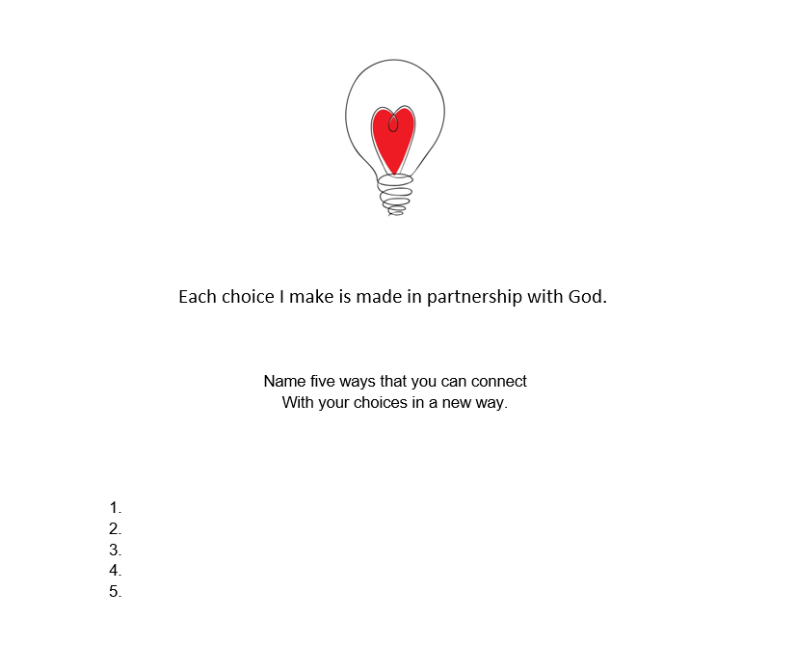

- Create a Story - Have students create two versions of a simple story where a choice changes the outcome. You can do this in a comic format. You can also take this further and have students try to repair a poor choice after the negative effect.

Week 3 – Seeing Things in a New Way

Opening Experience
This week we take a look at our 3rd basic unity principle which speaks to our perspective, or how we see things. If we can help ourselves see things differently, we can make better choices and see more opportunities.

Activity Choices

#1 Unity Basic Principle Activity – “I create my experiences by what I choose to think and what I feel and believe.” Think about this, our 3rd basic Unity principle.
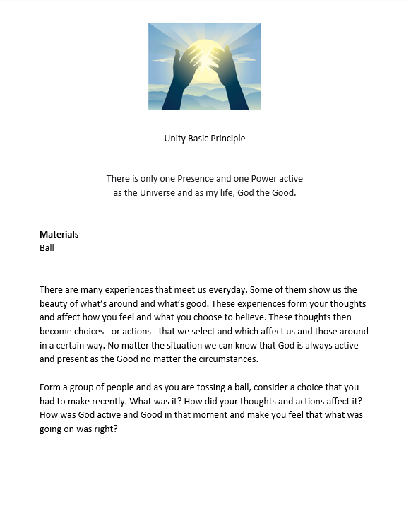

#2 Growth Mindset For Kids - 3 Steps To Help Kids With Mindset | SEL Choices & Self-Awareness For Kids - https://www.youtube.com/watch?v=iEQLBOw2W1w

#3 Let us continue to process by capturing our thoughts about what our 3rd basic Unity principle means to us. Next, write about what seeing things in a new way means to you.

Meditation Zone
Every day is a new day, take some time to refresh in meditation. Don’t forget to capture your thoughts and feelings as you proceed through the activities.

- A New Day- A Fresh Start-Morning Meditation
https://youtu.be/iC6OJh_KfM0?si=uO_2XwU-fFe2_Pr-

- Reflection
Write or draw a picture about your experience in your journal

- Sacred Table Activity
Take some time to reflect and add a memento to your sacred space that represents someone/people you’re especially grateful for.

Media Room
Welcome back to the media room. Watch this video and take in the mindset of a champion given by a young student. Focus on these mindsets and then reflect on them when you are going through the discussion questions.

- TED-Ed Student Program - The Mindset of a Champion
https://www.youtube.com/watch?v=HtuocZaVh7M

- Reflection Questions
- What did Carson Byblow say a “Growth Mindset” is?
- What did he say a “Fixed Mindset” is?
- Which mindset do you think you have?
- How could changing your mindset help you see things in a new way?
- How could this type of mindset help create self-responsibility?

Creation Station Activities
Let’s get creative with some new tools so that we know our perspective. Really dive deep into acknowledging yourself. Also, have fun and be creative.

- Character Trait Cubes - Have students decorate the cube and put the trait in the middle. For instance, print CARING in the middle. Then write an ‘I Will……. statement on each side of the cube. Decorate and make cubes.

- Responsibility Chart – Kids can create a chart of their daily or weekly duties, and it can be hung on a wall, etc.
Material –
- Packet of Wooden clothespins
- 1 piece of cardboard or card stock
- 1 piece of ribbon
- 2 washi tape
Method -
- Label wooden clothes pins with chores or responsibilities.
- Put a piece of washi tape on each pin to color code them.
Cut cardboard or card stock to a suitable size, decorate, and thread ribbon through the top to hang it.

Week 4: Activating Hope

Opening Experience
How can we activate hope in us and around us? One way to do this is by recognizing the beauty in everything and looking for the good. This is something that only we can do for ourselves. So, it would be a responsibility we have in order to make the world a better place for everyone.

Activity Choices

- Unity Basic Principle Activity – “I do and give my best by living the Truth I know. I make a difference.” Think about this, our 5th basic Unity principle.

- Responsibility Is For Everyone | Letters From Kids With Mister Brown - https://www.youtube.com/watch?v=AH3clGnNJbs&list=PLJcUCLV0PazDQz8z6aZdTcH9VeY46Vm7r&index=9

- Let us continue to process by capturing our thoughts about what our 5th basic Unity principle means to us. Next, write about how this can activate hope in your life and in others.

Meditation Zone
Activating hope requires focusing on positive thoughts and feelings. Let’s meditate and center to find that positive space.

- Mindful Meditation for Kids - https://www.youtube.com/watch?v=VZ_wdeog5Ek

- Meditation Reflection
Prayer for Protection
The Light of God surrounds me.
The Love of God enfolds me.
The Power of God protects me.
The Presence of God watches over me.
Wherever I am, God is!

Media Room
Activating hope in youth is very important cause you are the future. Ishita Katyal wants to tell you not to wait til you grow up to follow your dreams. Watch her Ted Talk and reflect on her thoughts.

- Why You Don't Have to Wait Till You Grow Up | Ishita Katyal | TEDxBhilwara https://www.youtube.com/watch?v=WlW7uzxurmA

- Reflection Questions
- Why does Ishita believe asking “What do you want to be when you grow up” is not a good question?
- What was the course she wished her school could include?
- What is an idea you could use to help yourself reach the top of the pyramid of Maslow’s Theory of Needs shown in the video?
- How can you empower yourself to realize your dreams now?

Creation Station
Let us practice using our imagination. Hopes and dreams begin there. Have fun with these activities and be creative.

- How to Visualize
Your ability to learn how to visualize depends on your ability to find a quiet place, clear your mind, and imagine your goals. Follow the 3 simple steps below to start visualizing.

- Goal Setting Hanger
- 6 Jumbo craft sticks
- 2 regular craft sticks
- Paint and paintbrush – if desired
- Paint pens or markers
- Craft pipe cleaner
- Hot glue
- Optional decorations, such as small pom poms, sequins, glitter, gemstones, stickers, etc. If desired
1. Line up the six jumbo craft sticks evenly, so they are lying horizontally side by side.
2. Apply an even layer of hot glue to one side of a regular sized craft stick and glue it vertically across one end of the jumbo sticks (as shown below). Repeat on the opposite side.
3. Apply an even coat of your choice of paint colour and then leave to dry.
4. Using the paint pens or markers, decorate both the top and bottom sticks as desired. Remind students to leave room on the middle four sticks for adding goals.
5. Once decorated, flip over and glue the pipe cleaner to the back of the board to form a hanger.
Then each student can fill in their own, personal goals.
Be sure to remind them to hang their Goals Board in a place they are sure to see each day as a reminder to keep working towards achieving their dreams.

Tweens & Teens Lessons

Week 1 – Being Accountable

Opening Experience
To recognize those things that are not good for us and develop a plan to release them.

Activity Choices

- Unity Basic Principle Activity – “God is all good and active in everything, everywhere.” Think about this, our 1st
basic Unity principle. We will begin to journal our thoughts and feelings in the third activity.

- Check Yourself - Accountability | Charlie Johnson | TEDxNormal - https://www.youtube.com/watch?v=bCteZqlwf-k&t=23s

- Reflection - Journaling is an excellent way to capture your thoughts and feelings. As we progress, they are there for us to look back on and use as tools or motivation. Let us begin that process by capturing our thoughts about what our 1st basic Unity principle means to us. Next, write about what “Being Accountable” means to you.

Meditation Zone

- 5-Minute Meditation for Positive Energy - 5 minute meditation for focus - YouTube

- Capture your thoughts or emotions as you finish your meditation in your journal

- Sacred Space
  - As we create our virtual Sacred Table, create one at home! Light a candle or use your phone's flashlight

- Unity Basic Principle Activity – “I am naturally good because God’s Divinity is in me and in everyone.” Think about this, our 2nd basic Unity principle. Write in your journal about what this means to you.

Media Room
One of our affirmations says. I am responsible for my feelings and actions, and I choose them wisely.

- Taken from The Andy Griffith Show's episode - "Baileys Bad Boy".
https://www.youtube.com/watch?v=SJjPni9V4EY

- Reflection
- In your own words what did Ron Bailey learn from witnessing the sheriff’s parenting choices?
- Do you remember a time when you needed to be accountable without being forced to?
- What did you do in this situation?
- Do you remember a time when you didn’t take responsibility for something?
- What was the outcome of this situation?

Creation Station

- Personal Responsibility Chart – Let's document what your day-to-day responsibilities are.
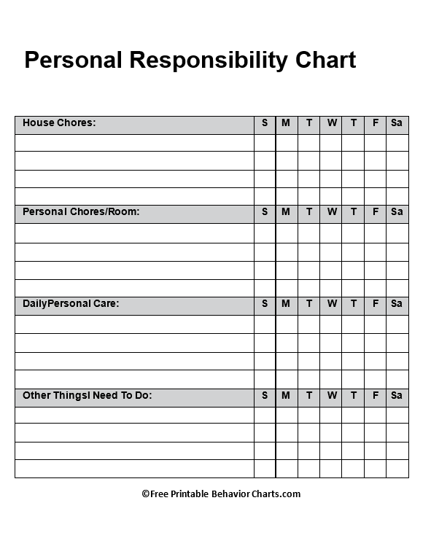

- Self-Inventory
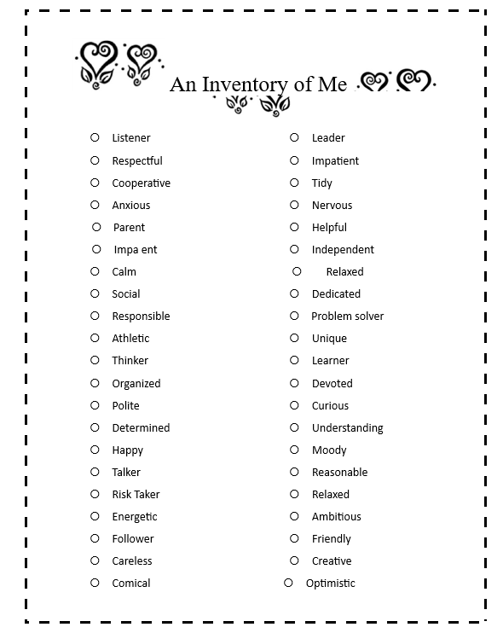

Week 2 – Making Choices

Opening Experience
Develop tools to see things in a new way.

Activity Choices

- 12 Power Activity - Instructions
Print the activity sheet and invite the children to read the affirmation that goes with the 12 Power and answer the questions by filling in the lines.
You might also have the children consider:
What does the affirmation mean to them?
What choices they’ve made recently and how they were able to see in a new way.
How they can work with the 12 Power and choose responsibly?

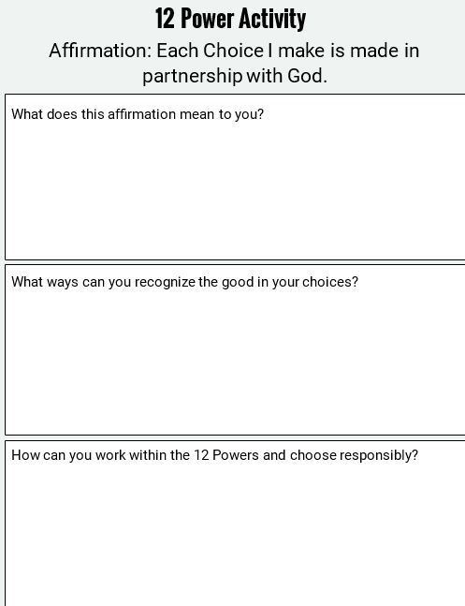

Before You Decide: 3 Steps To Better Decision Making | Matthew Confer | TEDxOakLawn - https://www.youtube.com/watch?v=d7Jnmi2BkS8

- Reflection

Choices and Consequences Writing Prompt
- What are some small actions that can make a big impact on the people around you?
- Describe a time when your actions had consequences you didn't anticipate.
- What kind of waves do you want to create How would you like to be remembered?

Meditation Zone

- Mindful Meditation for a Powerful Mind - https://www.youtube.com/watch?v=mZxcw2rPWxU

- Reflection
Capture your thoughts in your online journal. Have you experienced days like in the video?

- Unity Basic Principle Activity – “Through affirmative prayer and meditation I connect with God and bring out the good in my life.” Think about this, our 4th basic Unity principle, and write in your journal about what it means to you.

Media Room

- Rudy (4/8) Movie CLIP - Fortune's Truth (1993) HD https://www.youtube.com/watch?v=Qoh3YkxuwVo

- Reflection
- How do you see yourself in this scene?
- Do you think Rudy has made a bad choice? Why?
- Can you think of a moment in your life where you needed to make a similar hard choice?
- How could you use the 3 steps to better decision-making to make a life decision like this?

Creation Station

- Decision Making Activity Sheet

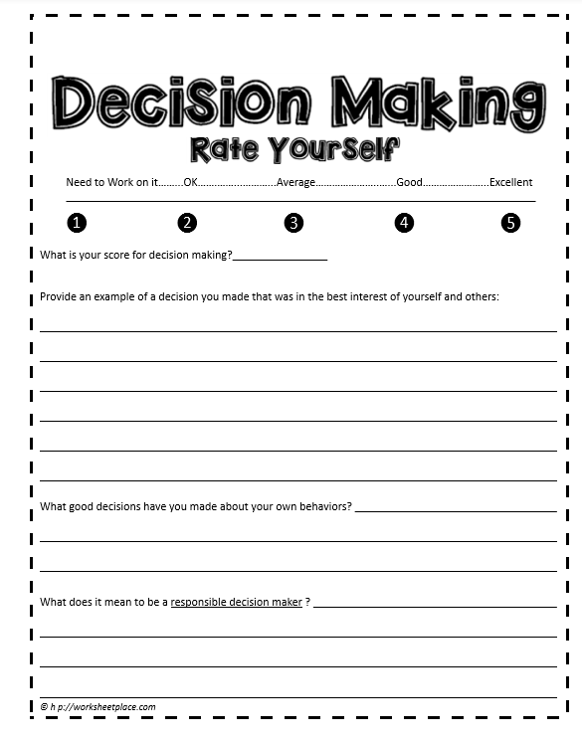

- Create a Story - https://www.toonytool.com/
  - Have students create two versions of a simple story where a choice changes the outcome. You can do this in a comic format. You can also take this further and have students try to repair a poor choice after the negative effect.

Week 3 – Seeing Things in a New Way

Opening Experience

Activity Choices

- Unity Basic Principle Activity – “I create my experiences by what I choose to think and what I feel and believe.” Think about this, our 3rd basic Unity principle.

- Growth Mindset Introduction: What it is, How it Works, and Why it Matters
https://www.youtube.com/watch?v=75GFzikmRY0&t=24s

- Let us continue to process by capturing our thoughts about what our 3rd basic Unity principle means to us. Next, write about what “seeing things in a new way” means to you.

Meditation Zone

- A New Day, A Fresh Start
https://www.youtube.com/watch?v=iC6OJh_KfM0

- Reflection
Express your thoughts about this mediation in your journal.

- Sacred Space
Place an item in your sacred space to remind yourself that each day is a fresh start.

Media Room

- Why Self-Efficacy Matters | Mamie Morrow | TEDxFSCJ https://www.youtube.com/watch?v=agwsjYg9hJ8

- Reflection Questions
- How could changing your perception help you see things in a new way?
- Have you experienced a moment like this in your life?
- How does this relate to self-responsibility?
- How does this relate to our 3rd Unity Principle?

Creation Station

- Responsibility Chart
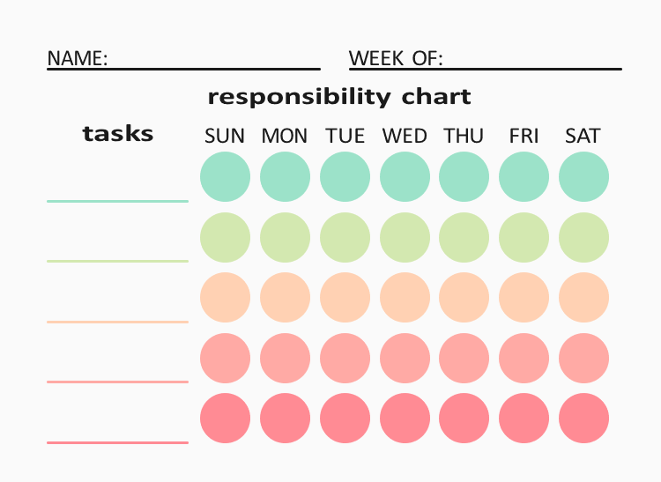

- Goal Setting Vision Board PDF
https://jackcanfield.com/blog/vision-board/

Week 4 – Activating Hope

Opening Experience
Recognize the beauty in everything and looking for the good.

Activity Choices

- Unity Basic Principle Activity – “I do and give my best by living the Truth I know. I make a difference.” Think about this, our 5th basic Unity principle

- The Science and Power of Hope | Chan Hellman | TEDxOklahomaCity
https://www.youtube.com/watch?v=qt0fRSx5Kl4&t=29s

- Let us continue to process by capturing our thoughts about what our 5th basic Unity principle means to us. Next, write about how this can activate hope in your life and in others.

Meditation Zone

- Reflecting on Hope, a Guided Meditation | Hello human kindness
https://www.youtube.com/watch?v=sJq_Cor09Qs

- Prayer for Protection
The Light of God surrounds me.
The Love of God enfolds me.
The Power of God protects me.
The Presence of God watches over me.
Wherever I am, God is!

- Sacred Table
Add an item that serves as a symbol of hope to you.

Media Room

- Coin Operated - Animated Short Film
  - https://www.youtube.com/watch?v=5L4DQfVIcdg&t=88s

- Reflection
- What is the message of hope that you get from this story?
- How do you think following your dreams relates to Self-Responsibility?
- What were some ways that the young man showed self-responsibility to achieve his goals?
- Write about a time that you had hope for a dream that seemed far out of reach, but perseverance helped you achieve it.

Creation Station

- How to Visualize
Your ability to learn how to visualize depends on your ability to find a quiet place, clear your mind and imagine your goals. Follow the 3 simple steps below to start visualizing.

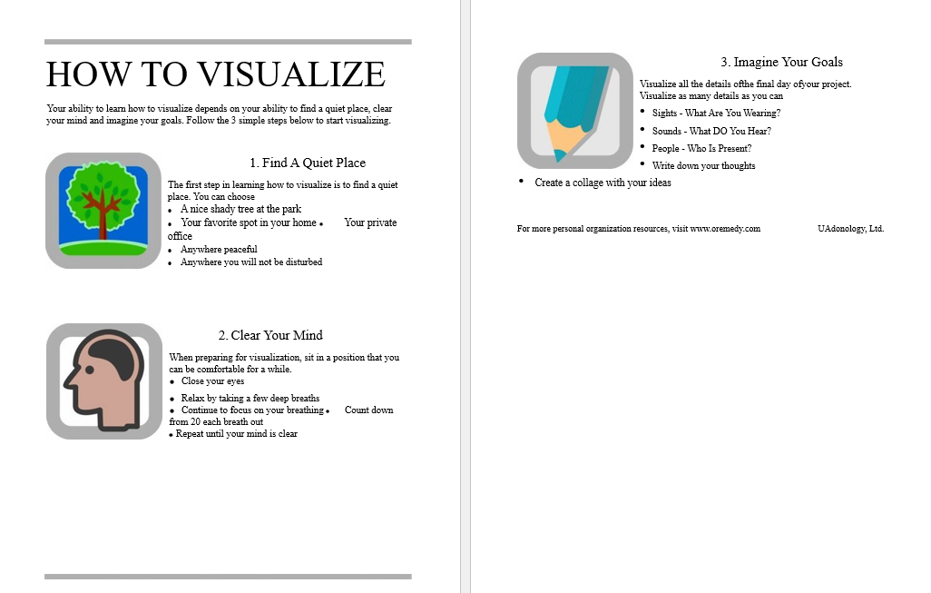

DIY Goal Setting Jar
A goal jar is another fun and creative way for teenagers to set and track their goals. Decorate and fill the jar with future accomplishments.

